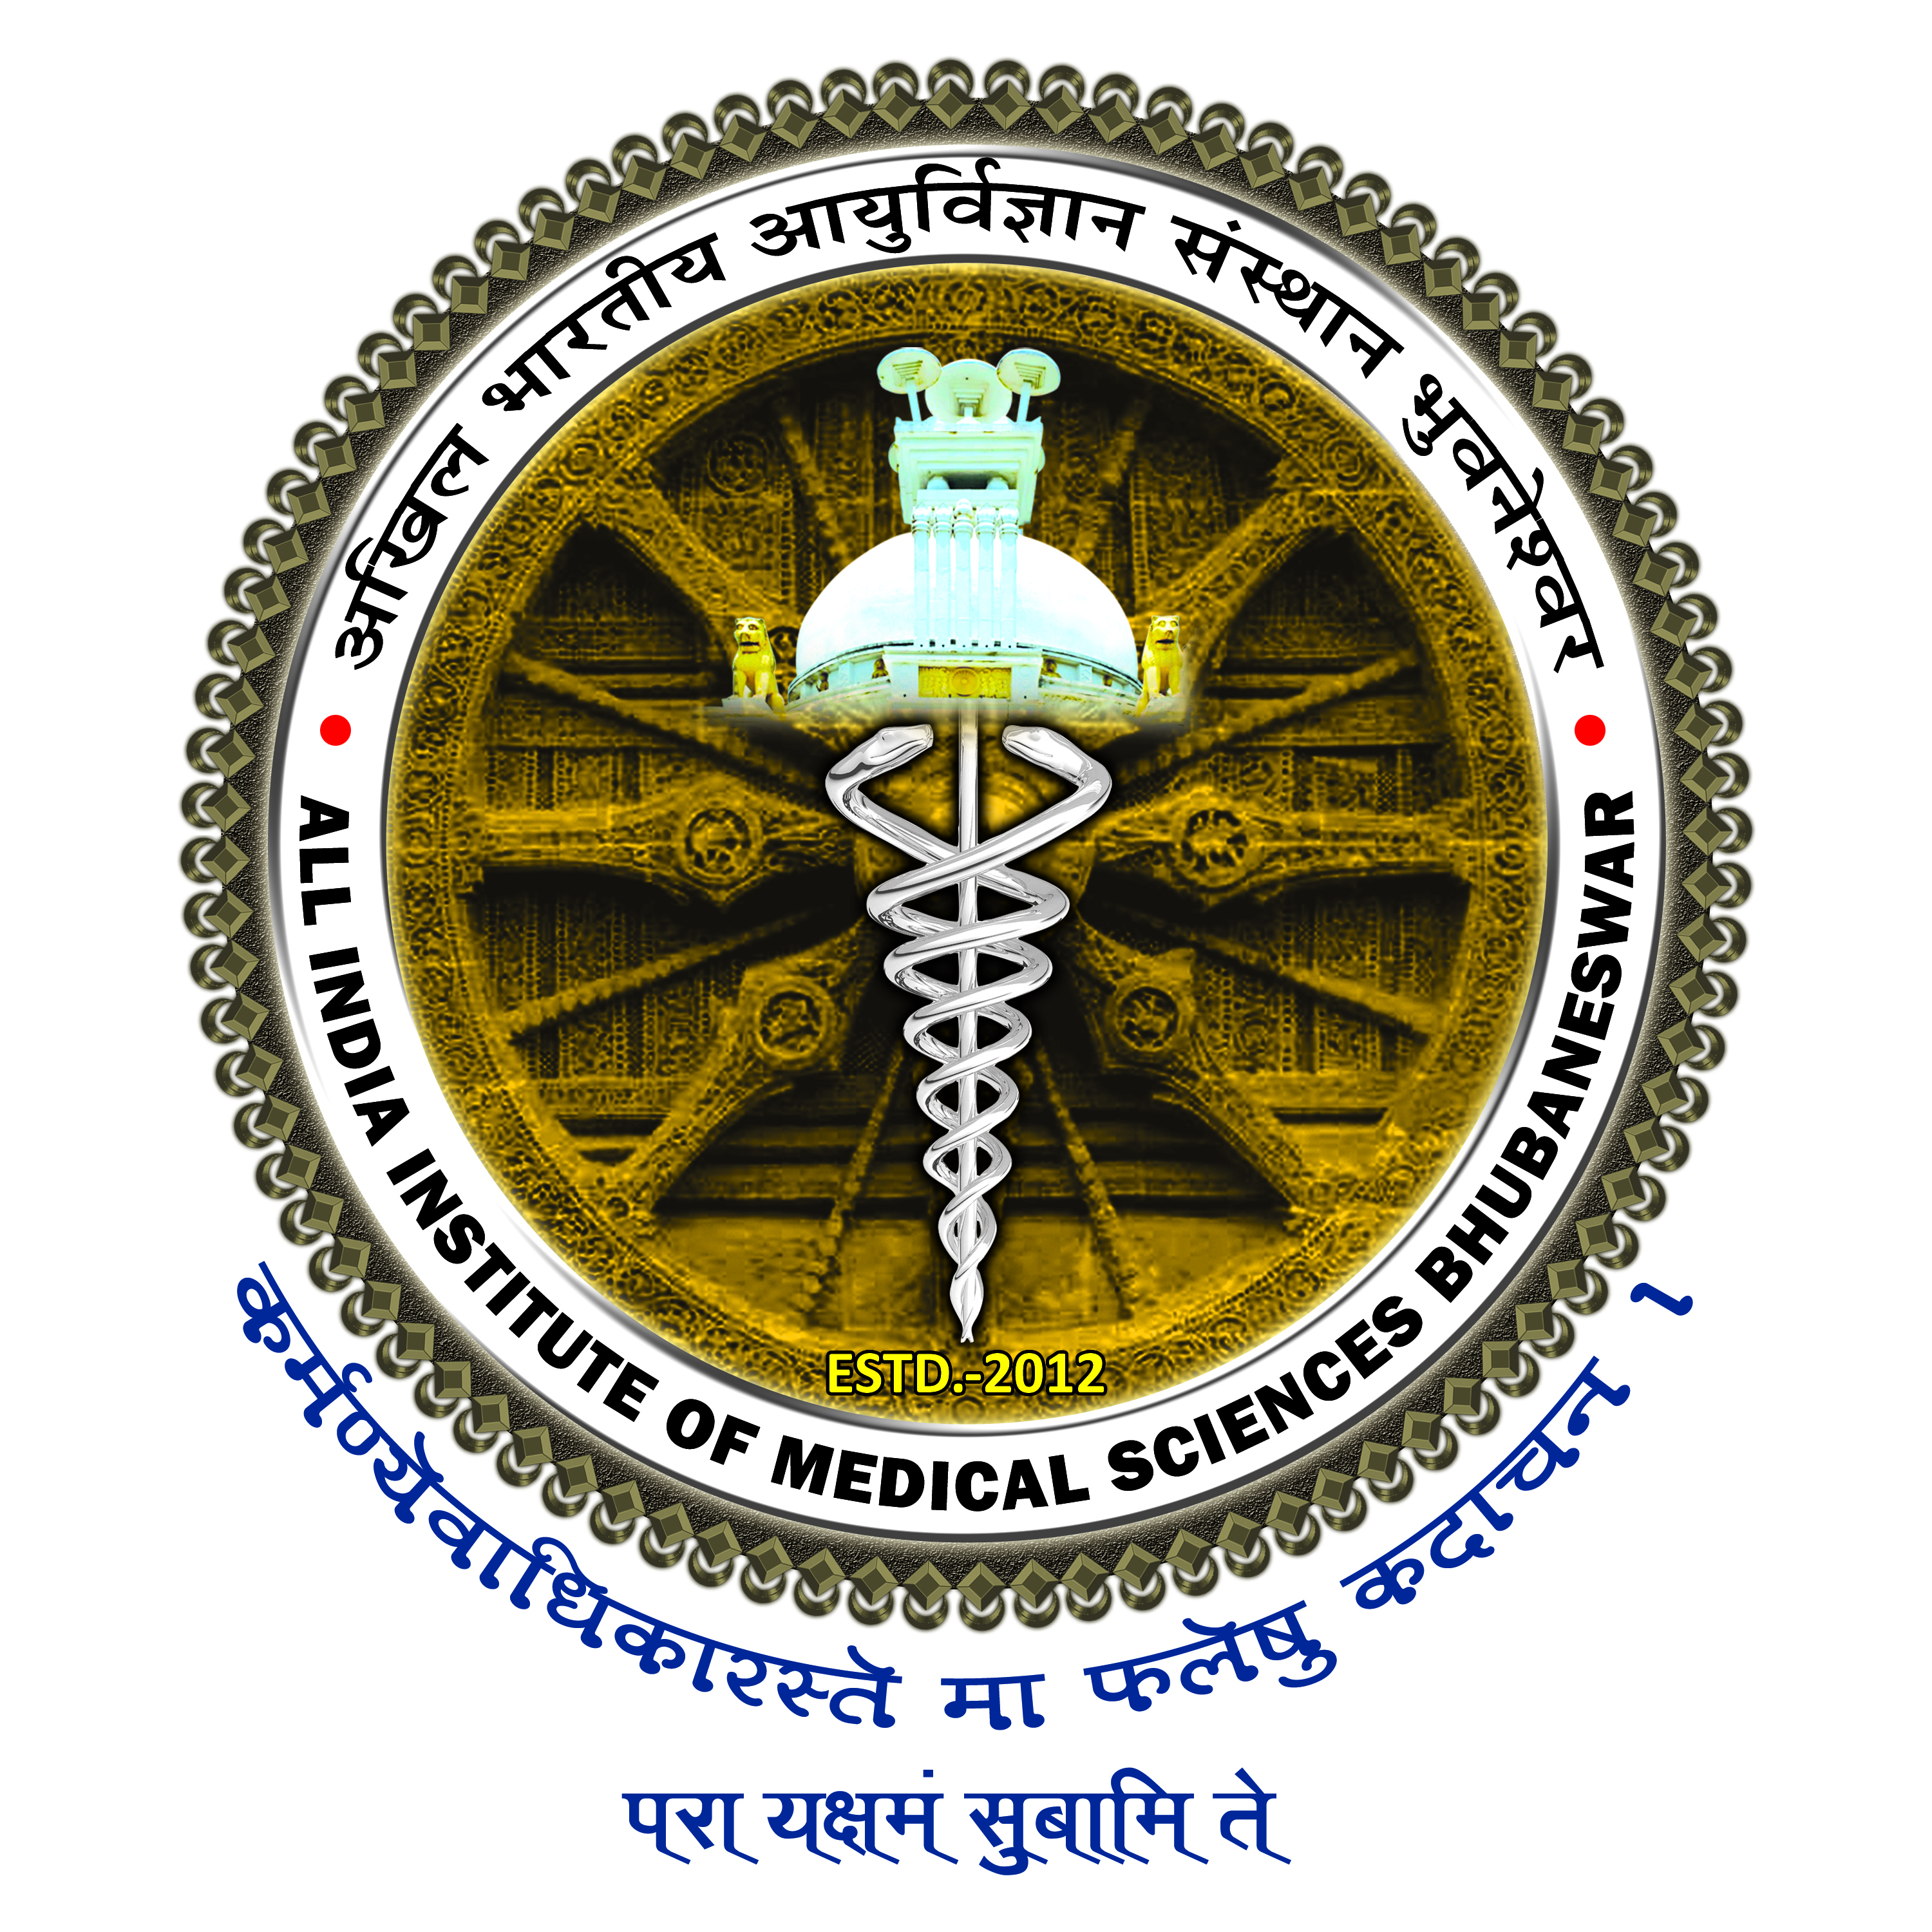

All India Institute of Medical Sciences, Bhubaneswar
Sijua, Post: Dumuduma, Bhubaneswar – 751019

UNDERTAKING

I do hereby undertake the responsibility of not serving any kind of beverage or food/ lunch/ dinner or any other perishable items inside the premises of Mini Auditorium including its corridors and any rooms of the Auditorium during the course of events organized by me.
I will be held responsible for making compensation in the event of any damage/ distortion made to the seats, electrical equipment’s or any other property of the Mini Auditorium during the course of the programme. Further, it is intimated that the below mentioned Event has been Funded / Non-Funded by the Institute.

Sign. of the Organizing Head/ Chairman/ Committee

Date:
Designation:

Event Name:

Date of organizing the Events:

