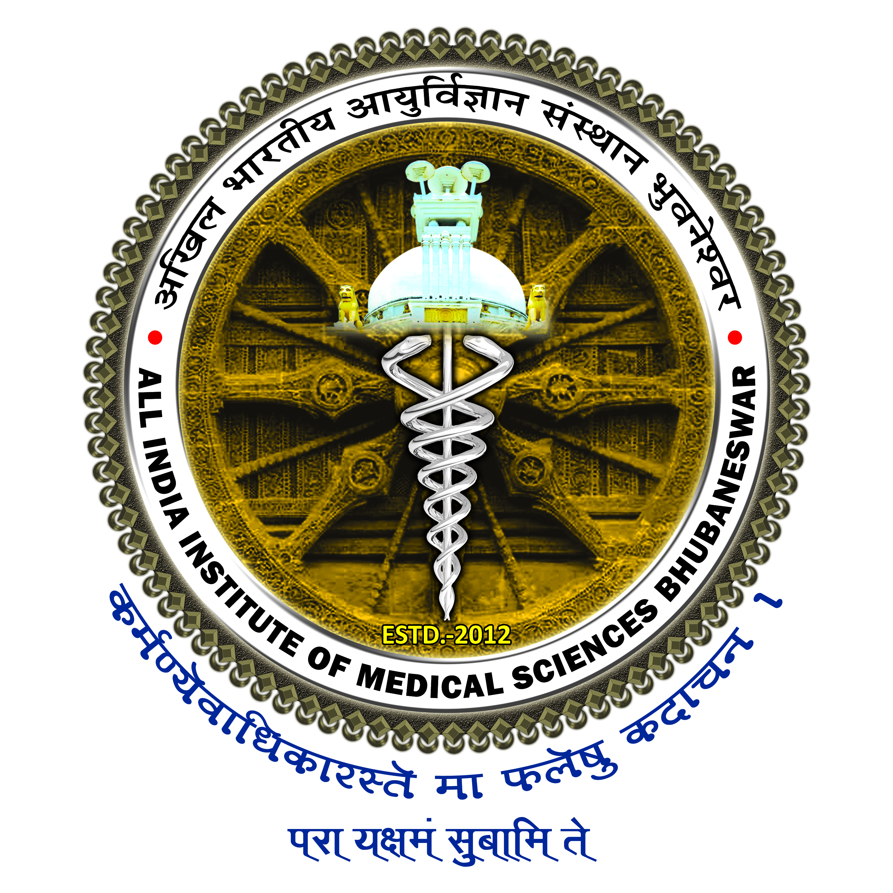

All India Institute of Medical Sciences, Bhubaneswar
Sijua, Post: Dumuduma, Bhubaneswar – 751019

UNDERTAKING

I do hereby undertake the responsibility of not serving any kind of beverage or food/ lunch/ dinner or any other perishable items inside the premises of Main Auditorium including its corridors and any rooms of the Auditorium during the course of events organized by me.
I also undertake and take responsibility for payment of penalty of Rs.25,000/- only in the event of any breach of condition of allotment of Main Auditorium as mentioned in the notice dated 13.01.2020. Further, it is intimated that the below mentioned Event has been Funded / Non-Funded by the Institute.

Sign. of the Organizing Head/ Chairman/ Committee
Date:
Designation

Event Name:

Date of organizing the Events:

