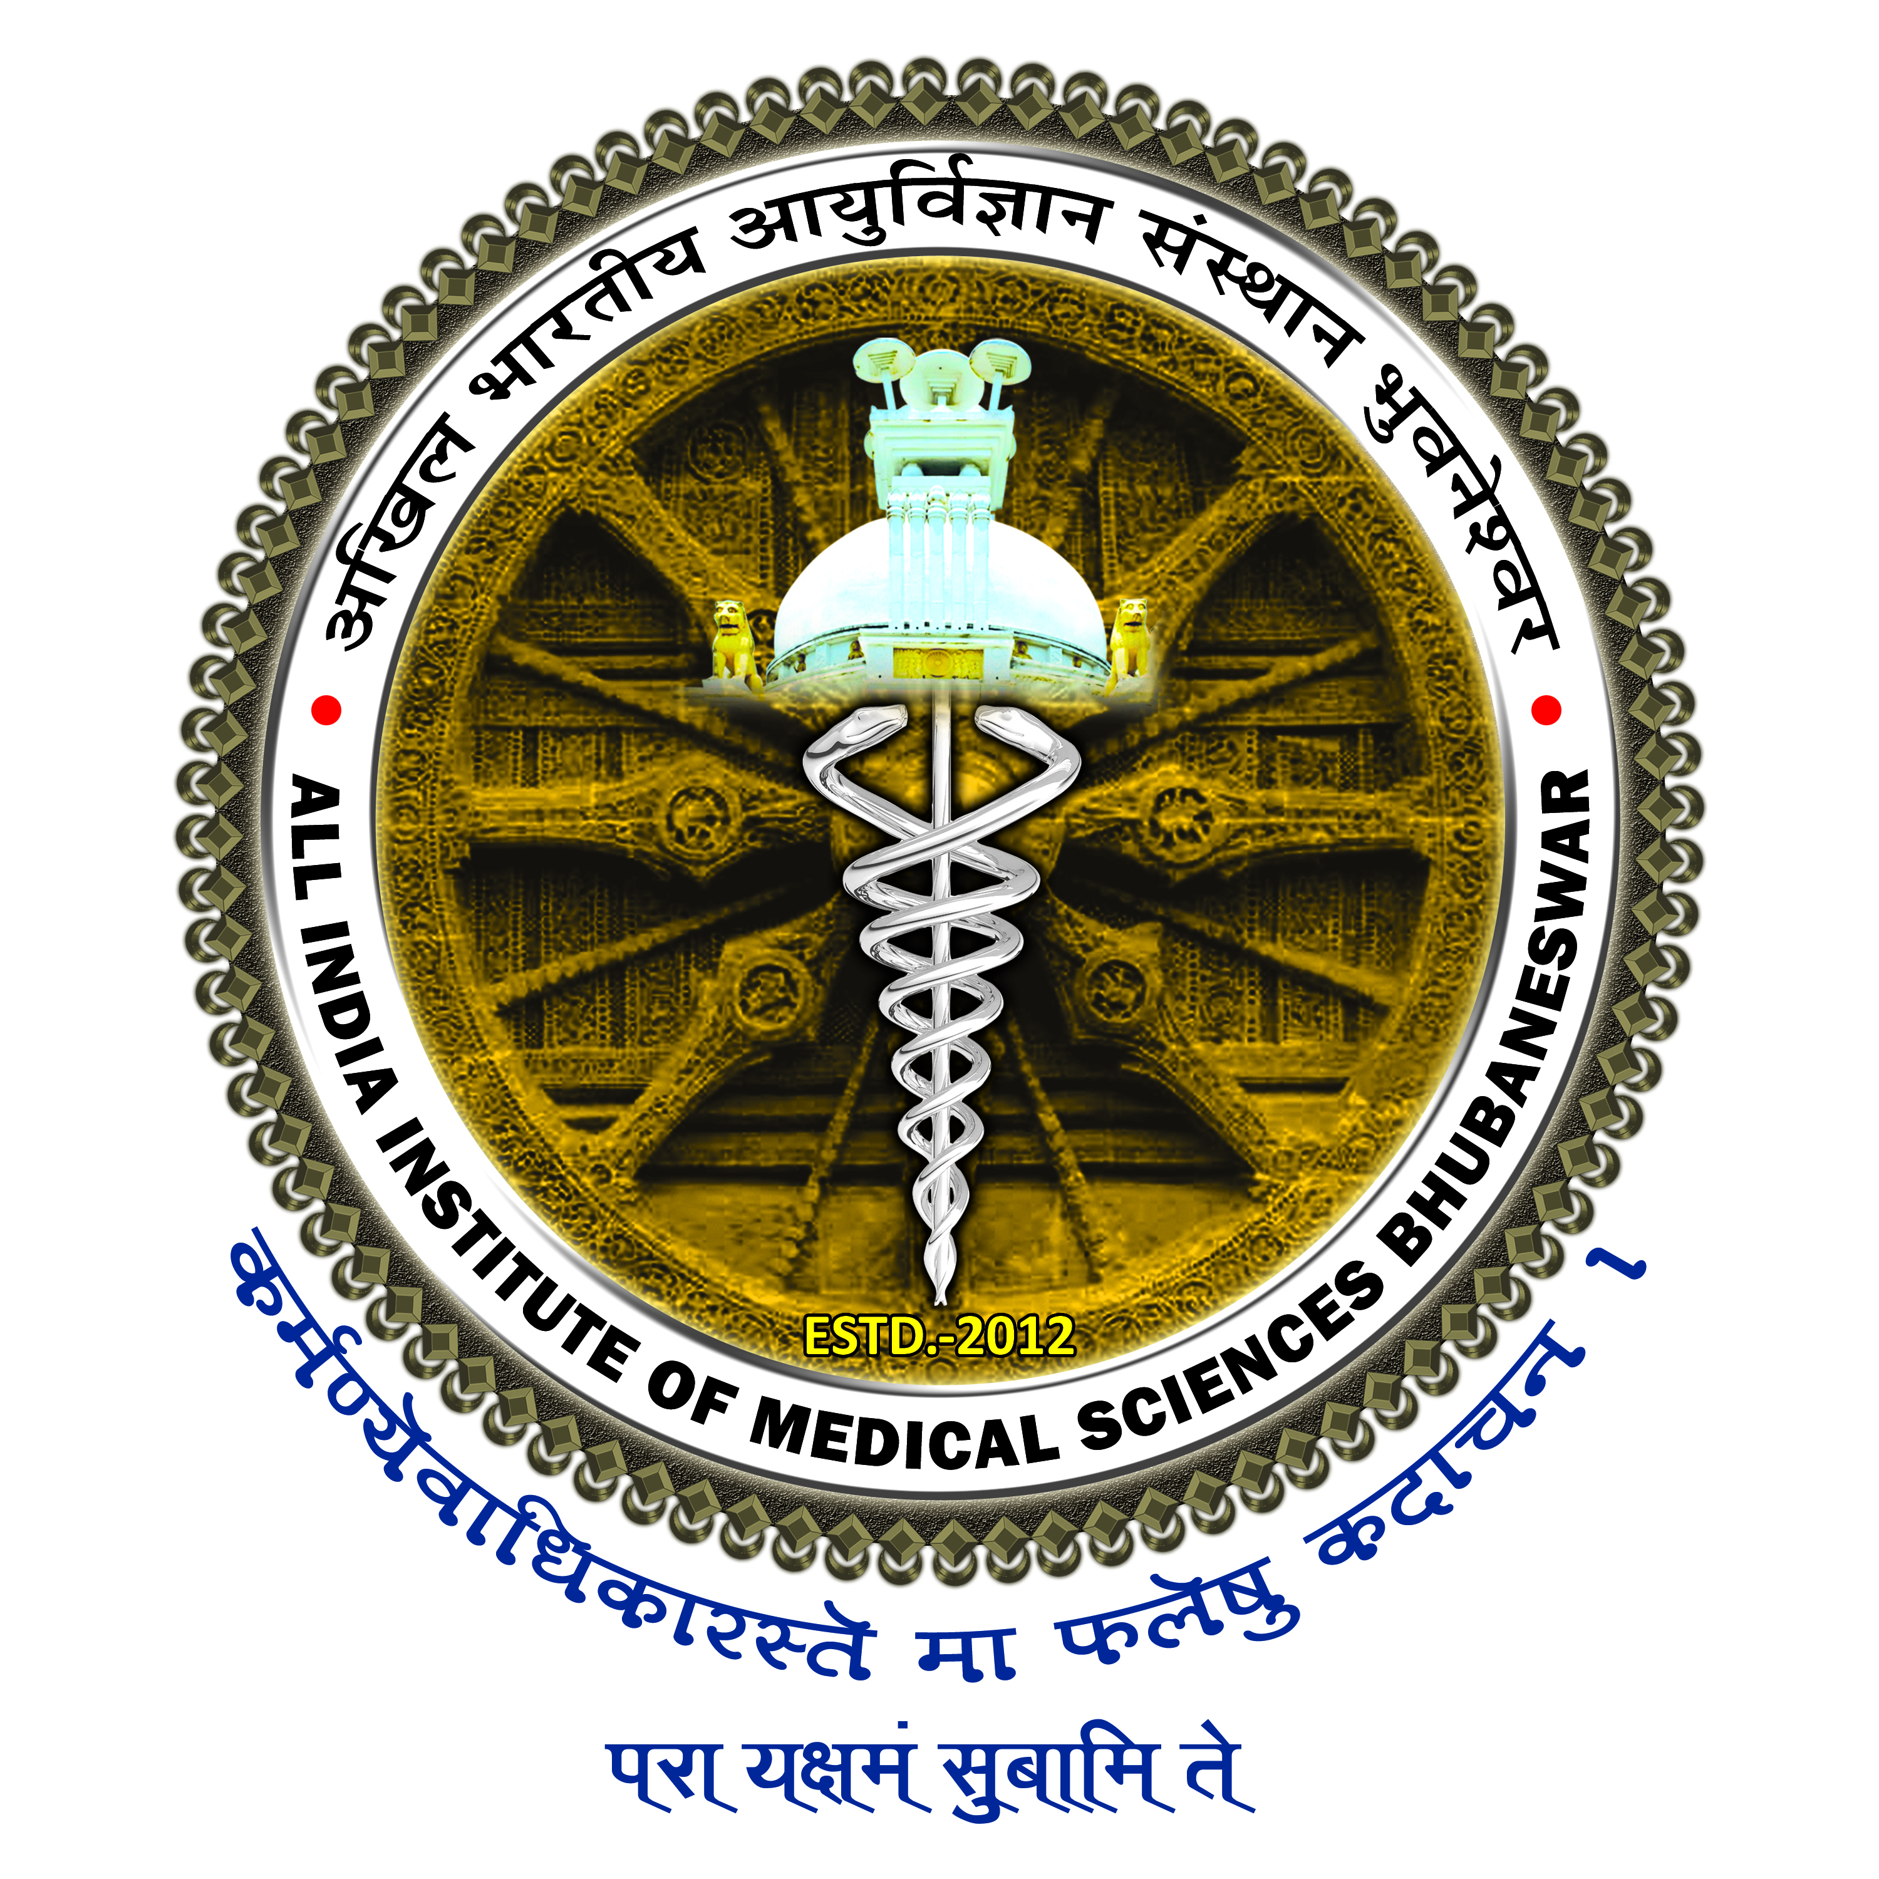

अखिल भारतीय आयुर्विज्ञान संस्थान, भुवनेश्वर
All India Institute of Medical Sciences, Bhubaneswar
सिजुआ,पोस्ट: डुमुदुमा, भुवनेश्वर -751019
Sijua, Post: Dumuduma, Bhubaneswar – 751019

PROFORMA FOR REIMBURSEMENT CLAIM FOR ARREAR OF CHILDREN EDUCATION ALLOWANCES (F.Y. 2023-24)

- Name of the Claimant:

- Designation:

- Department:

- Number of children for claim of CEA Arrear for F.Y. 2023-24:

- Previous paid amount for CEA reimbursement during F.Y. 2023-24:

- Application NO. of CEA Arrear Bill:

- Total CEA Arrear claim amount as per eligibility for the F.Y. 2023-24:

Signature of the Claimant

FOR OFFICE USE ONLY

- Demand No.:

- Amount already paid to the claimant towards CEA Reimbursement for the F.Y. 2023-24:

- Total admissible amount to be pay towards Arrear of CEA Reimbursement:

Dealing Assistant Asst. Admin Officer Accounts Officer/DDO

